Linear regression

1)def create_y(x):
res = x*5 + 3 + np.random.randn(len(x)).reshape((len(x),1))*0.3
MSE : 0.09

If we change 0.3 to 0.2 MSE reduces to 0.03,and if we change that to 0.1 MSE reduces to 0.01, if we go on decreasing the randomizer value MSE goes on decreasing.

2) Increasing test data to 20 :
X_test = x[-20:]
Y_test = y[-20:]
predicted equation:
y = [5.00005319] * x + [2.98130486]

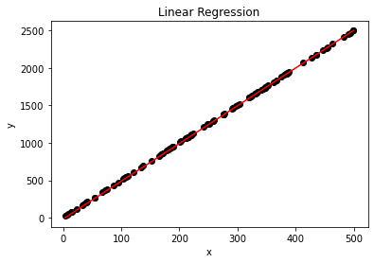

Polynomial regression

1) * Polynomial regression with degree 1:
polyfeature = PolynomialFeatures(degree = 1)
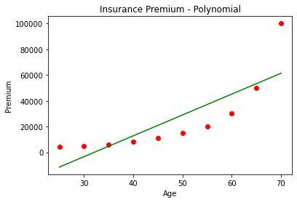

*Polynomial regression with degree 2:
polyfeature = PolynomialFeatures(degree = 2)
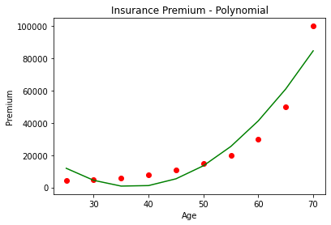
* Polynomial regression with degree 3:
polyfeature = PolynomialFeatures(degree = 3)
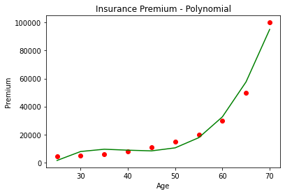
Among degree 1,degree 2 and degree 3
Degree1 and degree2 is under-fitted while degree3 is writefitted.Polynomial regression with degree > 3 results in over-fitting.

2) The insurance claim predicted for age 70 is as follows:
* Polynomial regression with degree 2:
polynomial prediction = [84663.63636364]
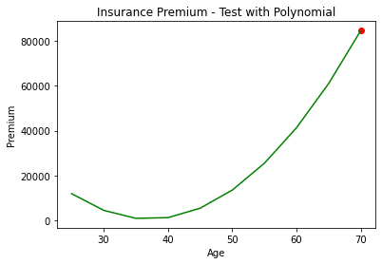
* linear regression:
linear prediction = [61345.45454545]

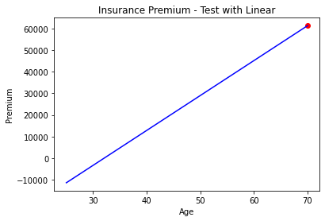

Linear and Polynomial regression

1) * Batch gradient method processes all the training dataset for each iteration of gradient descent .
*Stochastic gradient method processes 1 training example per iteration. Hence, the parameters are being updated even after one iteration in which only a single sample has been processed .

* Mini-batch gradient method works faster than both batch gradient descent and stochastic gradient descent. Here b examples where b<m (m be the number of training sample)are processed per iteration .

2) Among Batch gradient, Stochastic gradient and Mini-batch gradient ‘Mini-batch gradient descent’ is ideal as this method works faster and creates a small batches from entire data set and this method also has more probability of finding global minima.

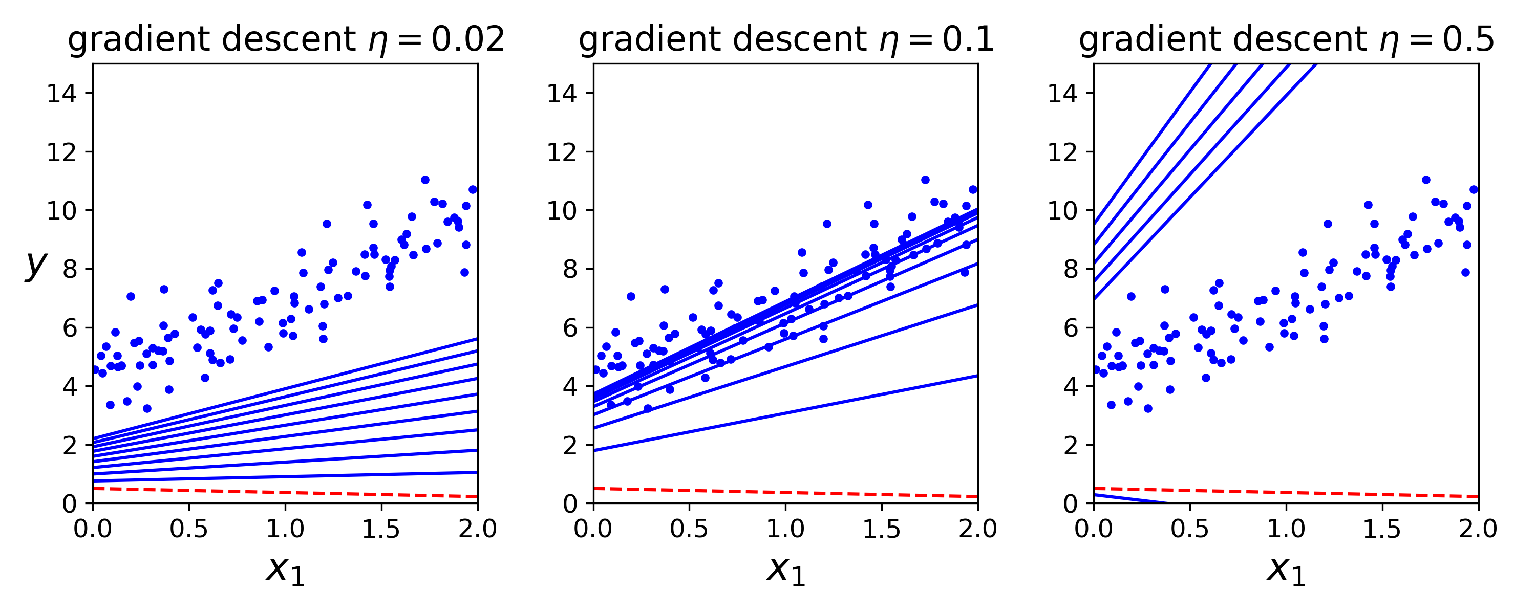
3) Learning rate gives us an idea of approaching the ideal solution by our ML model.

From the above plots we can see that when learning rate is 0.02 the rate of hopping in finding the ideal solution is very low and this results in consuming a lot of time as though we get ideal solution and if the learning rate is large such as 0.5 this results in very big hop for each iteration and has more probability of missing the ideal solution.
But if the learning rate is in between these values such as 0.1 this takes a moderate jumps for each iteration and has very high probability of finding the ideal solution in less time.

4)
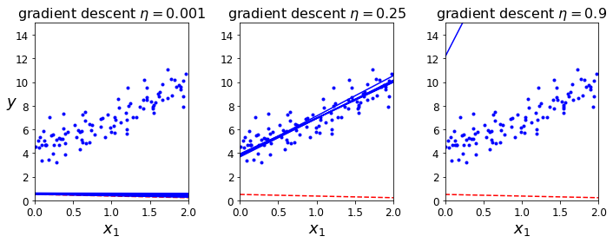

When the learning rate is 0.001 it takes a takes huge amount of time to find the ideal solution as the jumps are very tiny for each iteration.

When the learning rate is 0.25 we’ll almost reach the ideal solution easily as hopping takes place at a moderate rate.

When the learning rate is 0.9 we’ll get a big hop missing the ideal solution.

